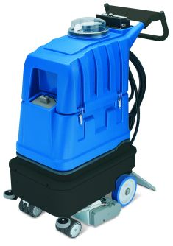
Elite-Battery is a battery self-contained machine for cleaning large areas of carpet. It washes, brushes and dries a stripe of 20” of carpet, moving forward.
Without power cord, it is easy to operate with Elite-Battery in large areas, for example in hotels, shopping centres, airports, convention rooms. Elite-Battery is a very silent extractor, since it works with 60 Decibels only. It is possible to adjust the brush and vacuum head pressure, according to the type of carpet. The water-flow can be regulated, for a maintenance low-moisture cleaning or a restoration deep-cleaning.
If equipped with the optional patented SMARTKIT system, it is possible to perform automatic chemical dosing, carpet pre-spraying and rinsing. The optional squeegee SQ720E allows to clean hard floor. An extra brush, specific for hard floor cleaning, is also available.

Main application fields: cleaning companies, hotels, conference halls, offices, banks, cinemas, theatres, shops, ferry boats, ships, airports, fitness centres, school, universities, shopping centres, places of worship, mosques and all places with large surfaces of carpet.
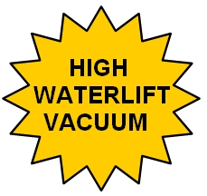
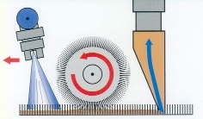

Injection-extraction cleaning with rotating brush

Advantages of Elite-Battery:
- It is possible to clean up to 5400 sq foot in one hour, thanks to the working forward system of the machine.
- Possibility to clean both carpet and hard floor with a single machine by using the optional squeegee SQ720E. The squeegee is connected to the machine thanks to a quick disconnect coupling and does not require to use any tool.
- Very silent working (60 decibels), that allows to use the machine with no discomfort for the worker and for other people. The machine can be used also during normal daily working time and in places sensitive to noise such as hotels, offices, banks.
- The tanks, with 50 litres each, allow a long working autonomy and reduce the idle time necessary for the tank filling and draining.
- The 3 stage high waterlift vacuum motor allows an excellent suction and therefore a very short drying time.
- The machine moves forward without effort, thanks to the propelling action of the rotating brush.
- The special profile of the vacuum head allows an excellent suction.
- The sprung vacuum head allows the best suction also in case of uneven floor.
- It is possible to regulate the pressure of the vacuum head according to the carpet thickness.
- The motor of the rotating brush is powerful and reliable and allows a very deep cleaning.
- Possibility to adjust the height of the rotating brush according to the kind of carpet or floor and also according to the degree of dirt.
- Brush motor with thermal protection against overload (useful in case of a wrong regulation of the brush height).
- Brush easily replaceable with no need of turning the machine over.
- Possibility to use an optional harder brush specific for hard floor.
- Stainless steel brush bearings for a longer life.
- Quick disconnect spray nozzles, which can be removed without using any tool. The nozzles can be cleaned easily. The complete connector with nozzles can be taken out of the machine without turning the machine over.
- All the controls are at a comfortable height for the worker.
- The spraying of water can be continuous or otherwise activated by a spray lever.
- Possibility to regulate the water flow, according to the degree of dirt and to the desired time for the drying.
- Possibility to connect the machine with optional tools for cleaning hard-to-reach corners. For example, once that the cleaning of a corridor in an hotel is completed, the carpet tool NS300 can be connected to the machine in order to clean inside the rooms.
- With the optional SMARTKIT-EL it is possible to perform automatic chemical dosing and carpet rinsing.
- Adding the pre-spray pipe and gun (PRESPRAY-EL) to the SMARTKIT-EL, it is also possible to pre-spray carpet before cleaning.
Other technical advantages of Elite-Battery
- Detachable tanks. The machine can be carried easily even in a small car.
- High density polyethylene tanks, very strong and made for lasting a long time.
- Transparent unbreakable cover, which allows to see the dirty water while it is sucked.
- Easy to reach hole for filling the tank with clean water.
- Drainpipe for easily emptying the recovery tank.
- Drain valve for draining completely the solution tank.
- The gaskets are not glued and replaceable by hand. Easy to clean and change.
- Brass quick-disconnect couplings, reliable and strong.
- Water pump with internal bypass, which allows an automatic regulation of the optimal water flow according to the tool used. Moreover, the bypass device makes the pump more reliable and avoids problems in the years.
- Water pump with external rectifier, specially sized for a greater reliability.
- Vacuum motor with thermal protection against overload.
- Vacuum motor treated against rust.
- Both motor and pump can work continuously.
- Modular design that makes the maintenance easier. The maintenance of the machine can be done at low costs.
Technical Data
Approximate performance (basic machine)*: | 2700-5500 sqft/h
Approximate performance (professional SET)*: | 3300-6000 sqft/h
Recovery tank capacity: | 14 Gallons
Solution tank capacity: | 14 Gallons
Vacuum motor:  Power:  Maximum waterlift:  Maximum air-flow: | Three stages – High Waterlift  850 W  100” H₂O  12 Gal/sec.
Pump with by-pass:  Power:  Maximum pressure:  Maximum water-flow | Membrane  80 W  9 bar  4,5 l/min
Drive motor: | 250W – adjustable speed
Cleaning width (carpet/floor): | 20 / 28 Inches
Number of nozzles: | 5
Brush: | 100 W  840 rot/min  18 Inches
Cable length: | 50 ft
Hose length: | optional
Weight (machine body): | 300 lbs including batteries
Weight (packaged machine): | 360 lbs including batteries
Dimensions: | 50 x 102 x 111 cm
Package dimensions: | 65 x 110 x 130 cm
Standard colours: | Blue
Tank construction: | High density polyethylene
Batteries: | 3 x 12 V fast charging type  38Ah  Tot 86 lbs
*The effective performance depends on the type of cleaning required: restorative deep cleaning - maintenance cleaning.
Complete machine for carpet cleaning, with internal battery charger 25A, with a complete set of 3 batteries | €

Suggested optional tools (see also Elite-Battery PROFESSIONAL SET)

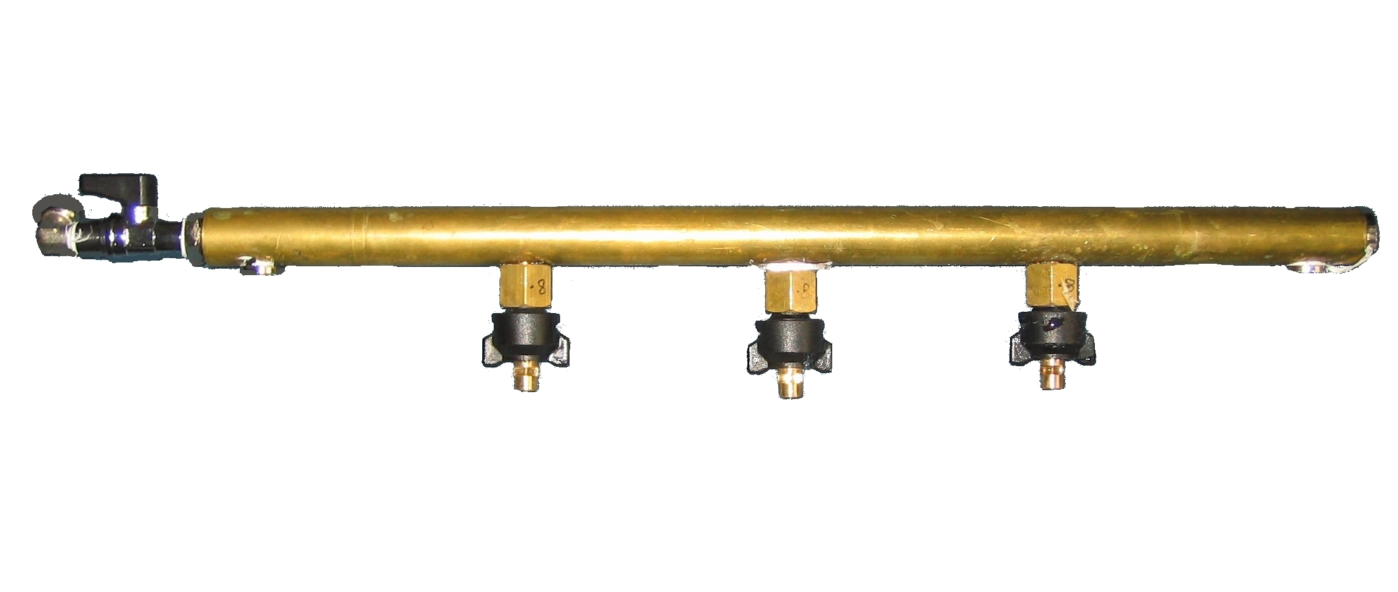 | 7572N-MAN | Optional manifold, for low-moisture maintenance cleaning, spraying solution on the cylindrical brush | €
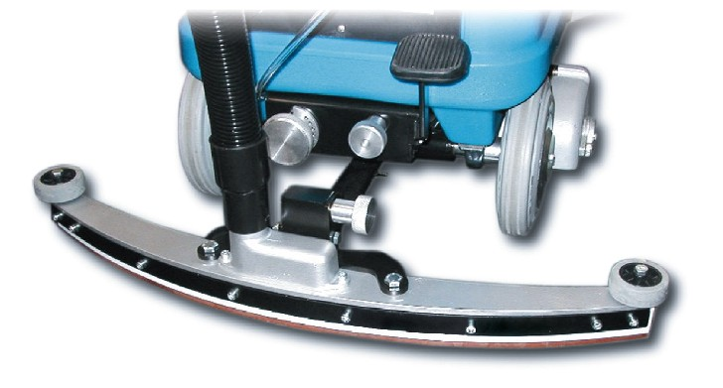 | SQ720E | Squeegee for hard floor cleaning, 720 mm | €
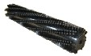 | 369-30 | Brush specific for hard floor cleaning. | €
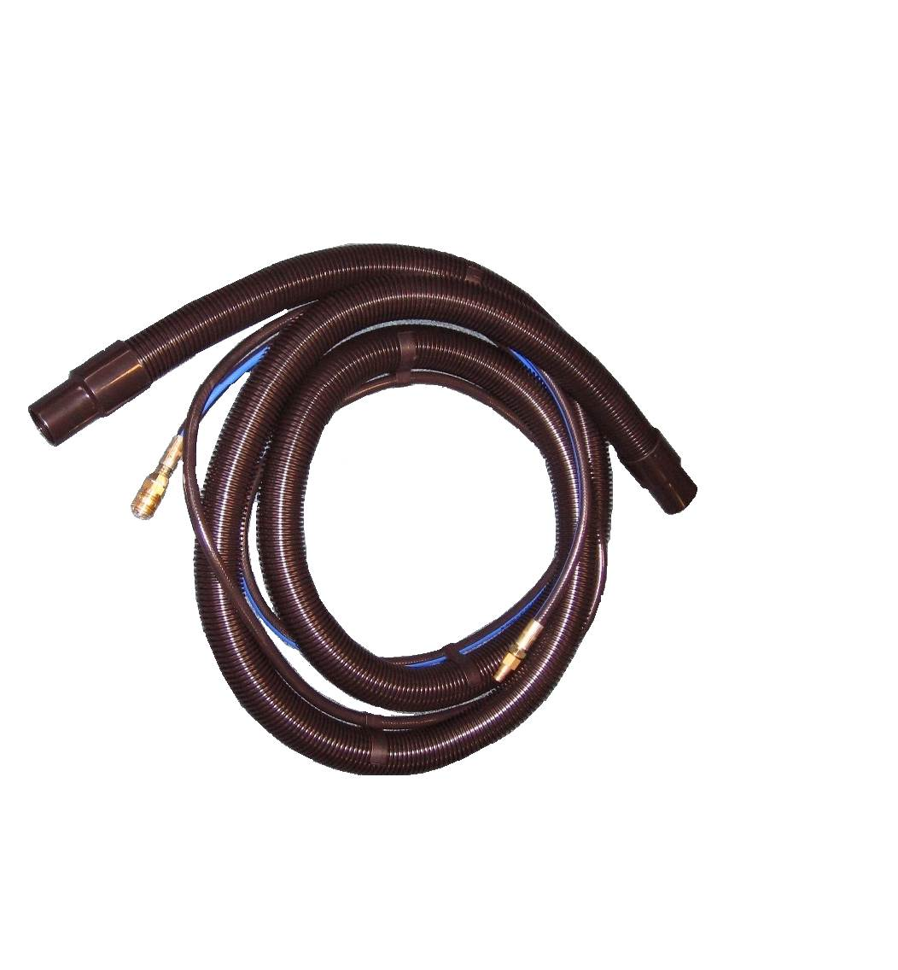 | H35- RAGNOL50-T | Vacuum and solution hoses, 5 m, Ø 38 mm, ragno solution pipe | €
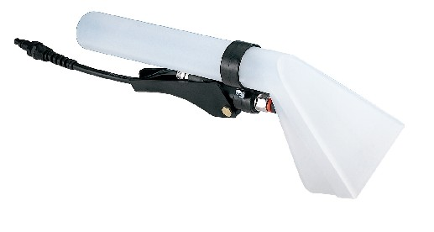 | NS10PN-M | Plastic hand tool, with 1 spray nozzle. | €
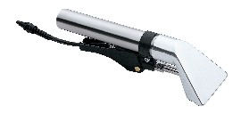 | NS10ALL-M | Aluminium hand tool, with 1 spray nozzle | €
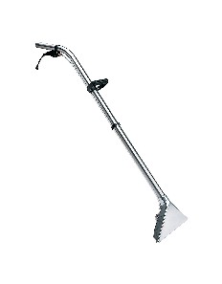 | NS300-M | Carpet tool with aluminium head, 3 spray nozzles, tubes in stainless steel | €
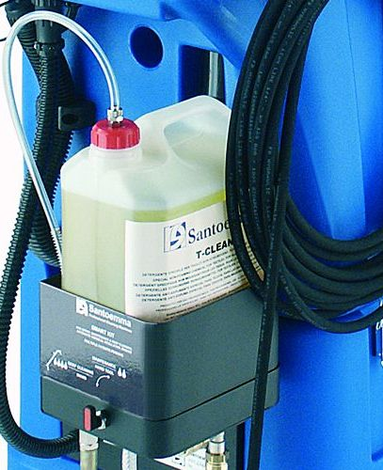 | SMARTKIT-EL | Kit for automatic chemical dosing, rinsing, carpet pre-spraying, low moisture/deep cleaning selection. Not including pre-spray pipe and gun (PRESPRAY-EL) for carpet pre-spraying. | €
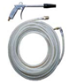 | PRESPRAY-EL | Complete pipe and pre-spray gun, to be added to SMARTKIT-EL, for carpet pre-spraying | €
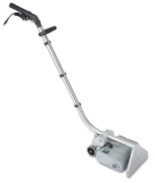 | NS270BRUSH | Special wand, 270mm wide, with a cylindrical rotating brush, to be used for cleaning carpet in combination with an injection-extraction machine | €
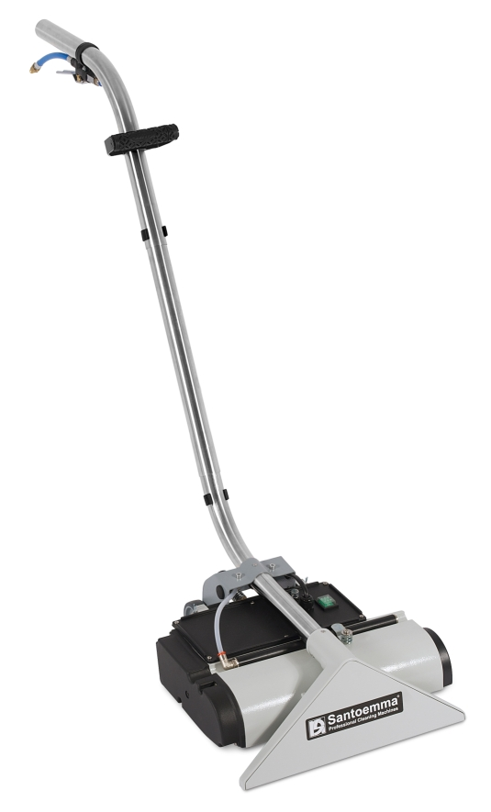 | NS400BRUSH | Special wand, 400mm wide, with a cylindrical rotating brush, to be used for cleaning carpet in combination with an injection-extraction machine | €
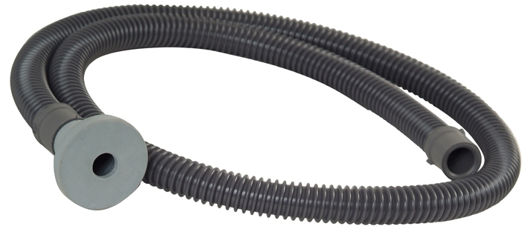 | 9022 | Hose for filling up the clean water tank easily. It can be used to connect the water tap to the machine tank, without spilling water. | €
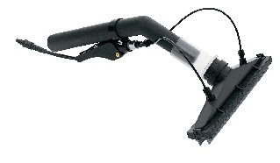 | HERMES-M | Tool which allows to wash and dry walls and windows. The solution is injected by 2 nozzles, which are inside the vacuum head, so that it is possible to clean a vertical surface without water dropping on the floor. Hermes is supplied with a brush slide and a rubber slide, to clean rough or smooth surfaces. | €
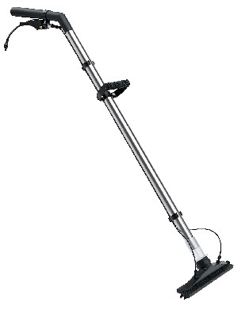 | NS270P-M | This tool works with the same principle of Hermes. Its two extensions allow to wash and dry hard floors, high walls and even ceilings. | €
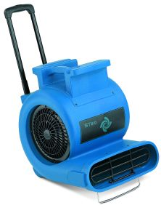 | ST810 | Three speed air blower, high performance, 1 Hp, 230V – 50Hz, for quick drying of carpet after cleaning. Equipped with wheels and extensible handle, easy to transport. Stackable. | €
Elite-Battery PROFESSIONAL SET


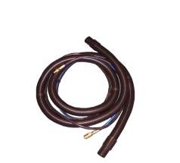
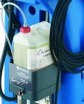
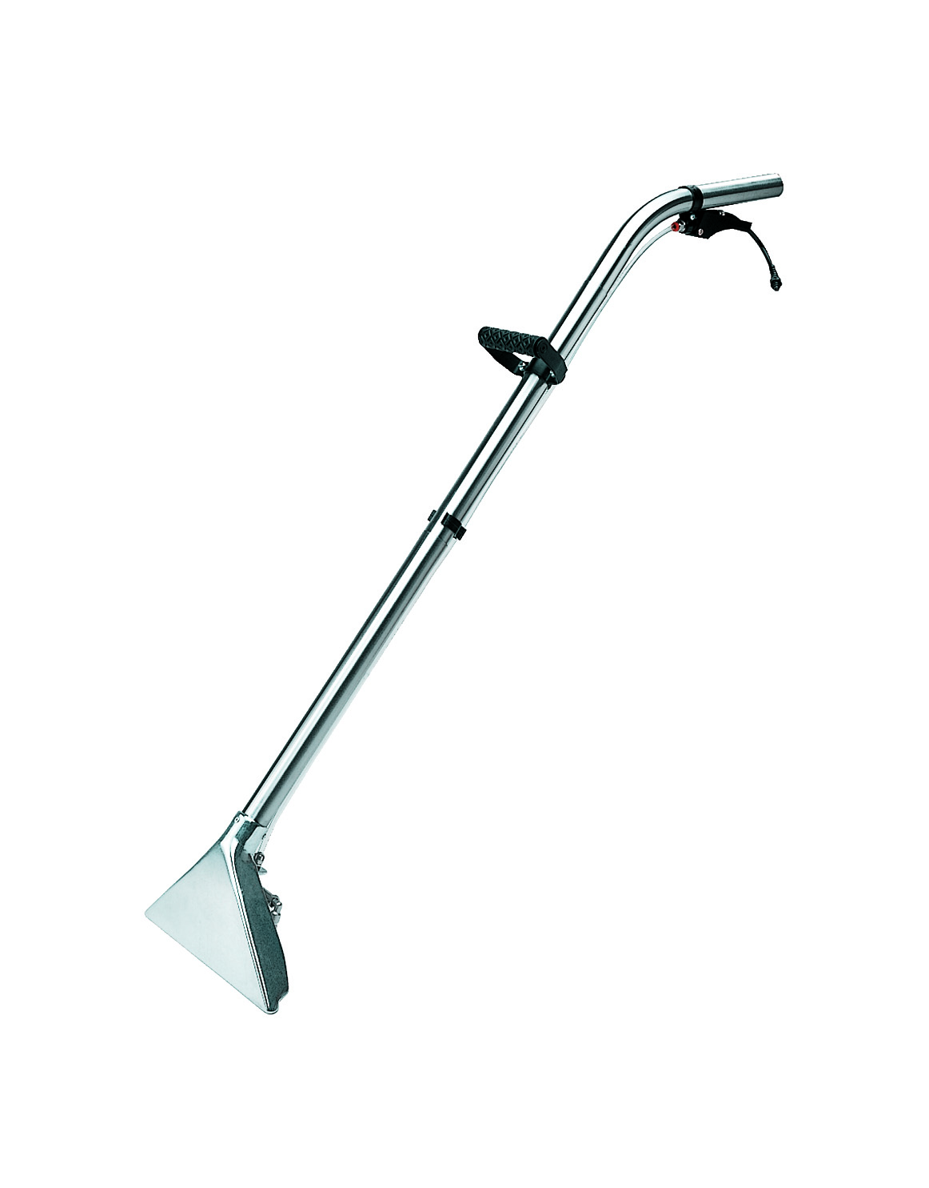
Smartkit-EL + Prespray-EL
Elite-Battery including batteries and charger
Hoses
H35-RAGNOL50-T

Wand
NS300-M

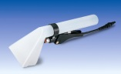

Hand tool NS10PN-M

Elite-Battery PROFESSIONAL SET includes:
- Machine body including batteries and charger
- hoses H35-RAGNOL50-T
- the wand NS300-M
- the plastic hand-tool NS10PN-M, for cleaning upholstery and hard-to-reach spots
- the complete SMARTKIT-EL with PRESPRAY-EL, to perform automatic chemical dosing, pre-spraying and carpet rinsing.

Advantages with Elite-Battery PROFESSIONAL SET:
  - The mechanical brushing action gives an excellent cleaning result, removing dirt completely from the base of carpet fibres. No residual dirt will re-emerge on carpet surface after few days!
  - Even a very dirty carpet can be completely clean in a single pass, reducing the time of cleaning operations.
  - Being able to clean in single pass, the amount of solution sprayed on carpet is not excessive and can be completely recovered by the machine’s high-waterlift vacuum system. As a result, carpet can be completely dry in one hour!

Complete Elite-Battery Professional set, including:  internal battery charger and a complete set of batteries  machine body, hoses H35-RAGNOL50-T, carpet tool NS300-M, hand tool NS10PN-M,  SMARTKIT-EL for automatic chemical dosing and rinsing, with pipe and gun PRESPRAY-EL for carpet pre-spraying | €

